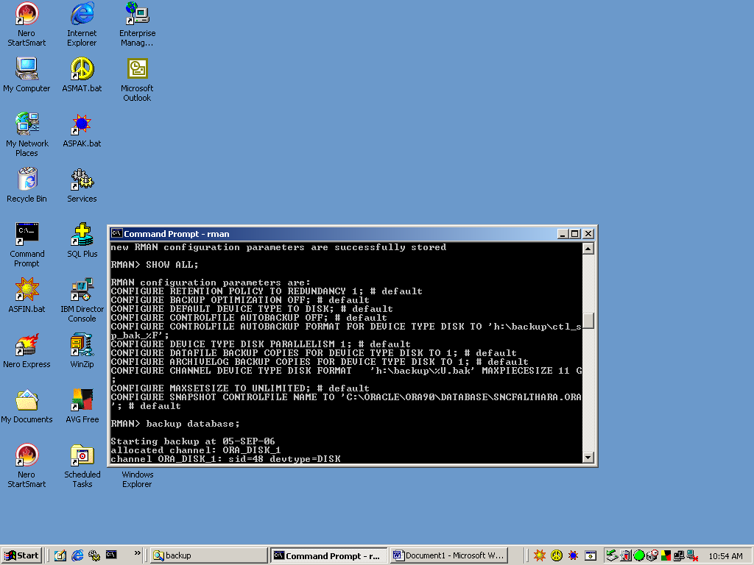

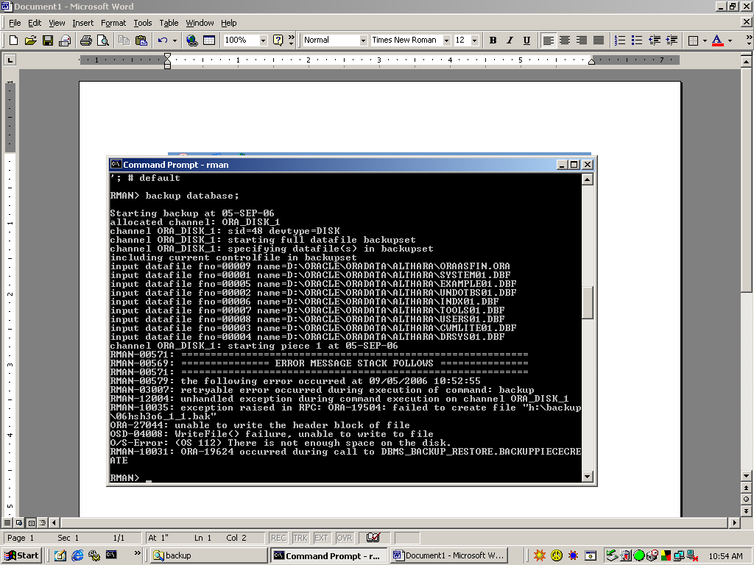

RMAN> backup database;

Starting backup at 05-SEP-06
allocated channel: ORA_DISK_1
channel ORA_DISK_1: sid=48 devtype=DISK
channel ORA_DISK_1: starting full datafile backupset
channel ORA_DISK_1: specifying datafile(s) in backupset
including current controlfile in backupset
input datafile fno=00009 name=D:\ORACLE\ORADATA\ALTHARA\ORAASFIN.ORA
input datafile fno=00001 name=D:\ORACLE\ORADATA\ALTHARA\SYSTEM01.DBF
input datafile fno=00005 name=D:\ORACLE\ORADATA\ALTHARA\EXAMPLE01.DBF
input datafile fno=00002 name=D:\ORACLE\ORADATA\ALTHARA\UNDOTBS01.DBF
input datafile fno=00006 name=D:\ORACLE\ORADATA\ALTHARA\INDX01.DBF
input datafile fno=00007 name=D:\ORACLE\ORADATA\ALTHARA\TOOLS01.DBF
input datafile fno=00008 name=D:\ORACLE\ORADATA\ALTHARA\USERS01.DBF
input datafile fno=00003 name=D:\ORACLE\ORADATA\ALTHARA\CWMLITE01.DBF
input datafile fno=00004 name=D:\ORACLE\ORADATA\ALTHARA\DRSYS01.DBF
channel ORA_DISK_1: starting piece 1 at 05-SEP-06
RMAN-00571: ===========================================================
RMAN-00569: =============== ERROR MESSAGE STACK FOLLOWS ===============
RMAN-00571: ===========================================================
RMAN-00579: the following error occurred at 09/05/2006 10:52:55
RMAN-03007: retryable error occurred during execution of command: backup
RMAN-12004: unhandled exception during command execution on channel ORA_DISK_1
RMAN-10035: exception raised in RPC: ORA-19504: failed to create file "h:\backup
\06hsh3o6_1_1.bak"
ORA-27044: unable to write the header block of file
OSD-04008: WriteFile() failure, unable to write to file
O/S-Error: (OS 112) There is not enough space on the disk.
RMAN-10031: ORA-19624 occurred during call to DBMS_BACKUP_RESTORE.BACKUPPIECECRE
ATE

RMAN> show all;

using target database controlfile instead of recovery catalog
RMAN configuration parameters are:
CONFIGURE RETENTION POLICY TO REDUNDANCY 1; # default
CONFIGURE BACKUP OPTIMIZATION OFF; # default
CONFIGURE DEFAULT DEVICE TYPE TO DISK; # default
CONFIGURE CONTROLFILE AUTOBACKUP OFF; # default
CONFIGURE CONTROLFILE AUTOBACKUP FORMAT FOR DEVICE TYPE DISK TO 'h:\backup\ctl_s
p_bak_%F';
CONFIGURE DEVICE TYPE DISK PARALLELISM 1; # default
CONFIGURE DATAFILE BACKUP COPIES FOR DEVICE TYPE DISK TO 1; # default
CONFIGURE ARCHIVELOG BACKUP COPIES FOR DEVICE TYPE DISK TO 1; # default
CONFIGURE CHANNEL DEVICE TYPE DISK FORMAT 'h:\backup\%U.bak' MAXPIECESIZE 11 G ;
CONFIGURE MAXSETSIZE TO UNLIMITED; # default
CONFIGURE SNAPSHOT CONTROLFILE NAME TO 'C:\ORACLE\ORA90\DATABASE\SNCFALTHARA.ORA
'; # default

