VIA ORDERORGANISATÖR

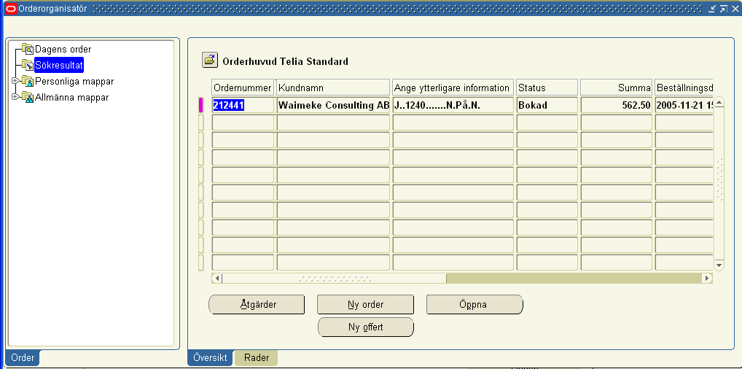

It is coming in Additional header Information.

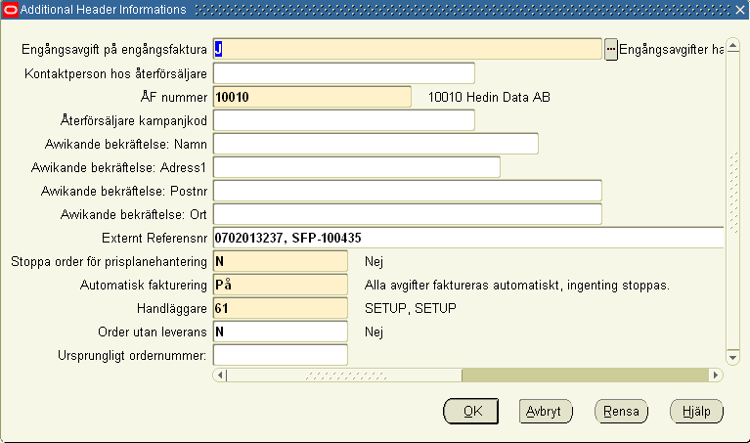

I want to change it to Swedish name like below. Ange ytterligare information

